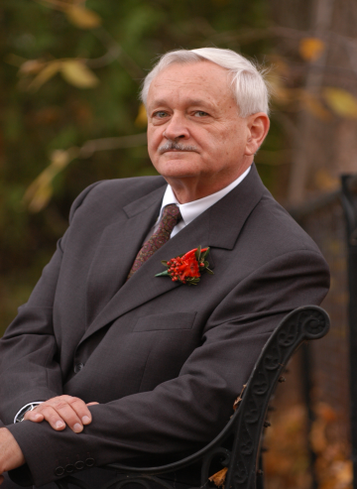

William Leiss, O.C., Ph.D., FRSC

Scientist, McLaughlin Centre for Population Health Risk Assessment, University of Ottawa: 1 Stewart Street, Room 311, Ottawa, ON K1N 6N5 Canada
Tel: 613-562-5800 (2116) / Cellular: 613-297-4300 / Fax 613-562-5380

Email: wleiss@uottawa.ca

Websites:
http://www.leiss.ca
http://www.blackholesofrisk.ca
http://www.herasaga.com

William Leiss is a Fellow and Past-President (1999-2001) of the Royal Society of Canada and an Officer in the Order of Canada.

From 1999 to 2005 he held the NSERC/SSHRC Research Chair in Risk Communication and Public Policy in the Haskayne School of Business, University of Calgary. This five-year chair program, with total funding of $1.25 million, was part of the MOTC (Management of Technological Change) strategic grants program; a consortium of Alberta-based industrial sponsors from the chemicals and petroleum sectors, led by Nexen Inc., provided one-half of the chair funding.

From 1994 to 1999 he held the Eco-Research Chair in Environmental Policy at Queen's University, Kingston, Ontario. The five-year Eco-Research Chair program was funded at a total of $1.3 million by the Tri-Council Secretariat (using funds from Environment Canada) and Imperial Oil Ltd. His earlier academic positions were in political science (Regina, York), sociology (Toronto), environmental studies (York), and communication (Simon Fraser). At Simon Fraser he was also Vice President, Research.

He is author, collaborator or editor for fifteen books and numerous articles and reports.

Three books deal with health and environmental risks: In the Chamber of Risks: Understanding Risk Controversies includes risk management case studies of genetically-modified foods, radio-frequency fields, pulp mill effluent, MMT, genetic engineering, voluntary initiatives, and CEPA. Mad Cows and Mother's Milk: The Perils of Poor Risk Communication (with Douglas Powell, 1997; second, enlarged edition 2004) and Risk and Responsibility, 1994 (with Christina Chociolko), contain detailed case studies of controversies over environmental and health risks in Canada and elsewhere, including: pesticides, electric and magnetic fields, food risks ("mad cow" disease, "hamburger disease"), chemicals (dioxins, PCBs), silicon breast implants, agricultural biotechnology, and bovine growth hormone.

Earlier books are The Domination of Nature (1972), The Limits to Satisfaction (1976), Social Communication in Advertising (1986, 1990, 2005), C. B. Macpherson (1988,2009), and Under Technology's Thumb (1990), all of which are currently in print. With the exception of Social Communication in Advertising, all of these titles are published by McGill-Queen’s University Press.

His latest book, The Doom Loop in the Financial Sector, and Other Black Holes of Risk, was published by The University of Ottawa Press in October 2010.

Over a period of thirty years he has worked extensively in a consulting capacity with industry and with Canadian federal and provincial government departments in the area of risk communication, risk management, public consultation, and multi-stakeholder consensus-building processes. He has been an advisor on issues dealing with pesticides, toxic chemicals (chlorine, dioxins, and others), tobacco, prescription drugs, electric & magnetic fields, genetic engineering, and many others.

He was a member of the Senior Advisory Panel for the Walkerton Inquiry (2000-2) and in 2000 was Chair of the Task Force on Public Participation for Canadian Blood Services; from 2008 to 2010 he was advisor on risk management to the Commission of Inquiry on the Investigation into the Bombing of Air India Flight 182.

In Fall Semester 2012 he was Senior Visiting Fellow at Cornell University’s Society for the Humanities, directing the program in “Risk@Humanities.”

Recent engagements include:
- Development of Integrated Risk Management Framework for BSE and CWD, National Centre of Excellence on Prion Diseases, Canada
- January and September, Presentations on Risk Management to the Public Executive Program, Queen’s University School of Business
- Consultant on Risk Assessment and Management of Carbon Capture and Storage, Carbon Management Canada (National Centre of Excellence)
- Consultant to CNSC/CEAA in connection with the Joint Review Panel on Low and Intermediate Level Nuclear Waste siting

September 2014

